1a. I am getting this error:

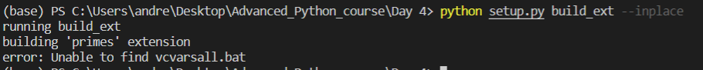

1b.

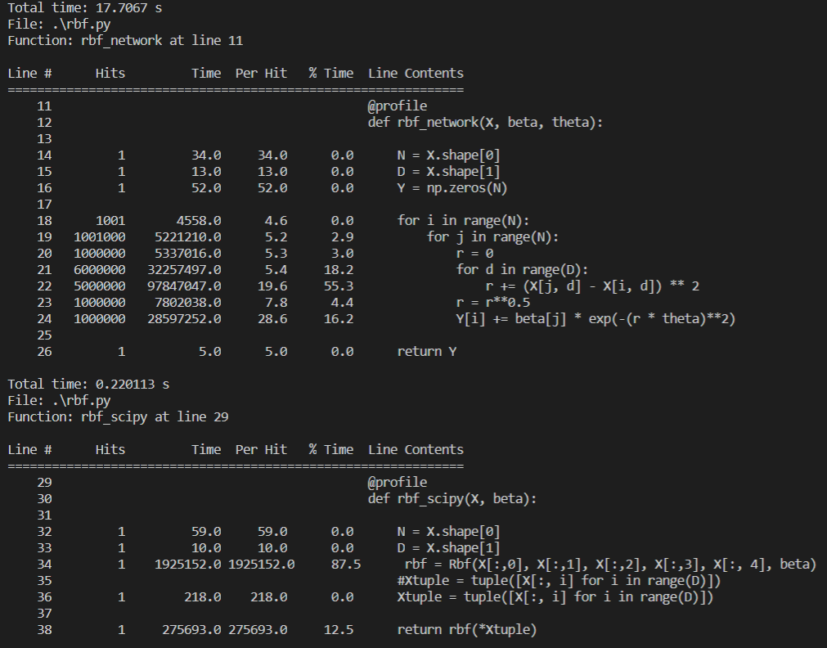

1c. The slowest part is the matric operation, it take the most time as can be seen in the figure above.

Scipy is faster because is uses numpy functions.

1d. I am getting this error

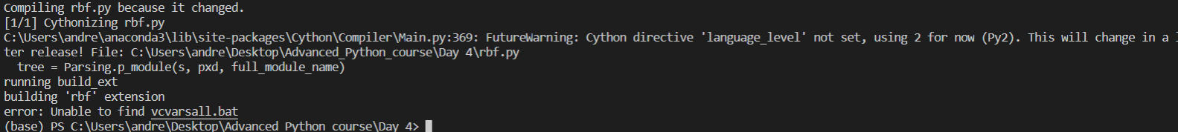

2a.

